User Interface Design “One-Pager” Document
Revision 0.1
ProxyClient Web Filter Advanced Configuration
Document Metadata
Current Author: Doug Baron | Last Modified: 3/16/2009
Original Author: Doug Baron | Creation Date: 3/03/2009
Document Phase: Early development | Change Rate: High
Document Currency: Current and active
Intended Audience: Engineering, PM, QA, Doc | Security: Corporate

CONFIDENTIAL INFORMATION
Copyright 2001-2008 Blue Coat Systems Inc. All rights reserved worldwide. No part of this document may be reproduced by any means nor translated to any electronic medium without the written consent of Blue Coat Systems Inc. Specifications are subject to change without notice. Information contained in this document is believed to be accurate and reliable, however, Blue Coat Systems Inc. assumes no responsibility for its use, Blue Coat is a registered trademark of Blue Coat Systems Inc. in the U.S. and worldwide. All other trademarks mentioned in this document are the property of their respective owners.

Revision History
Revision | Date | Author | Comments
0.1 | 3/16/2009 | Doug Baron | Initial draft
(Note: To insert graphics into this document, copy the image file into the same directory as the document, then link to it; don’t insert the graphic.)

Description
This document details the set of changes to be made to the ProxySG advanced management console to support configuration of user-based web filtering. The functional specification of this feature is ProxyClient - Client-Side Policy - User Based Policy - FSD.doc.

Design
All user interface changes needed to create, view, modify and delete user-based ProxyClient web filtering rules will be confined to the Policy tab in the ProxyClient Web Filtering tab set.
Changes made in the panel will be put into effect using new CLI commands that have been specified for this feature.

Replace and repurpose the “All Categories” tree control
In SG 5.4, the categories tree control has checkboxes at each node in the tree. Checking a node adds that category to the policy rule set with the default action Block. Un-selecting a tree node removes that category from the rule set. Selecting a rule from the active set displayed in the rule set table does not select that category tree node, so rules cannot be removed directly.
In Propane, any category included in the rule set can have many actions – a default action and any number of actions associated with different users or groups. To facilitate this functionality, the category tree will become a selection component in a rule creation form. (See figure 1)

Rule Builder form
The Rule Builder form is the set of controls used to create new category rules.
To create a new rule, all three form fields – category, user-group, action – must have valid values. The Add button can then be pressed to create a new rule.
When a rule is added, it will appear in the Selected Rules table in the selected state, ready to be moved or deleted.
Operation details:

Category Browse
The Category Browser is a tree control showing the full category hierarchy, similar to the existing All Categories tree control, but without checkboxes at each node. Instead, each node will visually indicate – using text or background color, frame or text - whether or not any rules have been assigned to that category. One possible expression of an “active” category node might be to underline the category name and append the default action followed by any the exception synopsis – consistent with the Category Rulebase table display.
Operation: Selecting a node in the category browser fills the Category Name text field with that category name. Conversely, when the Category Name field value changes, the browser will expand to and select the matching node.

Category Search
The Category Search form allows the entry of a url for category look-up.
Operation: the user must select the Find tab to reveal the category search form, then type or paste a url into the URL field.
Pressing the Find Category button will display the found category at the bottom of the form and set the Category field in the Rule Builder form below.

Category field
Category is an active-predictive text entry field.
Initial state: “Enter a Category”
Typing: as the user types, the category field will actively fill the text area an a drop-down menu with categories that begin with the user entry. The Up/Down cursor, Tab and Enter keys will navigate and select or ignore auto-populated entries in the standard way.
Other category selection tools include the Category Browser and the Category Search sub-tabs in the form.

User-Group field
User-Group is an active-predictive text entry field.
Initial state: “Enter a User-Group”
Typing: as the user types, the user-group field will actively fill the text area an a drop-down menu with existing user-group names in the rulebase that begin with the user entry. The Up/Down cursor, Tab and Enter keys will navigate and select or ignore auto-populated entries in the standard way.
No other tools for user-group lookup will be provided in this release.

Action field
Action is a drop-down menu with a Select an Action prompt followed by three choices: Allow, Warn and Block.
A required field, an Action selection must be made to enable the form’s Add button.

Add
The Add button accepts the form field values and adds a new rule to the Rulebase.
Upon Add, the new rule will appear in the Rulebase table of active rules.
Extra: also display status: “<category- name> Rule Added”
Extra2: follow the status with an Undo button or link.

Replace and extend the Selected Category Rulebase table
The policy category table must show not only the default action, but also any user-based actions that override that default. It should make it easy to browse and modify details within large rule sets, but also provide assistance in the early stages of policy creation.

Web Filtering Policy Status / Help
Near the top or below the rule set table, show a summary indicating the number of categories and user-groups represented in the collection.
A special Help area will be visible in the early stages of policy configuration.
When no rules have been created, display the first-time guidance text:
The default action is to <allow|block> all web content from all users. You can <block|allow> content in specific categories or for specific users by creating rules using the Rule Builder form on the left side of the display.
When a single rule has been created, display the next level of rule set guidance with the text:
A rule has been created to <action> the <category-name> category. You can create exceptions to this rule for specific users or groups with the Rule Builder.
Provide a link or widget to hide the guidance. In the future, we may want to allow this choice to be persisted.
Stop showing category rule guidance when 3 or more category rules or any user-group rule exceptions exist.

Web Filtering Policy Rule Set Table
The table display should make is easy to change the action of, promote, demote, or delete existing user-based category actions.
The table display should allow selection, promotion, demotion and deletion of an entire category.
Content
The table will show three columns of data, titled Category, User-Group and Action
All category rules are initially displayed in the table, order determined by creation and any explicit reordering that has since been applied.
Rows showing user-group exceptions are expanded, preceding the Default category action in the last row.
The Default category itself always appears at the bottom of the list and cannot be removed.
Operation
The Content Rules table will support selection of a category or a user-group rule within a category.
Selection will be visually indicated in a standard way, probably using by a frame.
Selection will populate the Rule Builder form with matching values to facilitate easy addition of new rule exceptions.

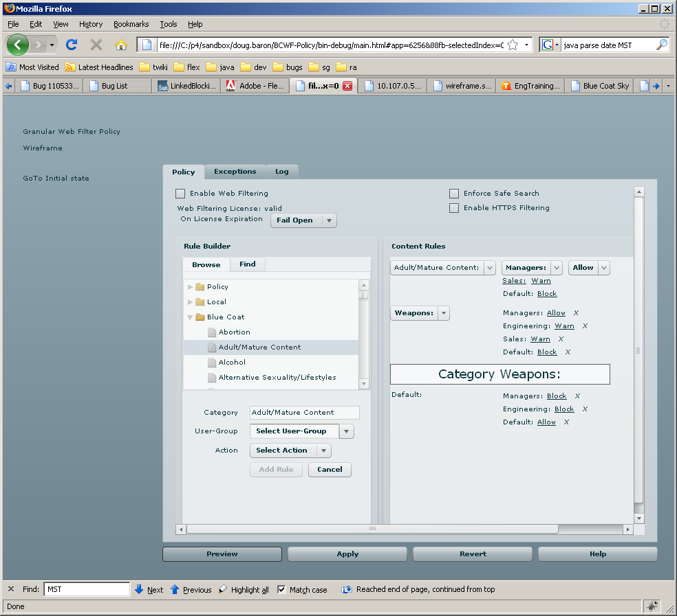
Figure 4: The Configuration->ProxyClient->Web Filtering tab set, Policy tab selected

Design Assumptions
None

Implementation Design
Implementation will be committed to the 5.5 branch when unit testing is complete.

UI
The current Configuration->ProxyClient screens will be extended as follows:
The General tab set will not change for the User-Base Web Filtering feature.
The Acceleration tab set will be not change for the User-Base Web Filtering feature.
The Web Filtering tab set will have major changes in the Policy tab, as detailed above (Figures 3, 4).
The Configuration->Content Filtering tab set may have changes for improved ProxyClient integration, but none specifically targeting the user-based policy feature.

CLI
CLI changes associated with this feature are detailed in the functional specification, ProxyClient - Client-Side Policy - User Based Policy - FSD.doc.

Security Impact
None

Policy Impact
User-based web filtering is a form of policy, but no changes to the VPM are targeted for this feature.

Integration and Testability
All Web Filter configuration error states – disabled, expired license, etc. – including display refresh on state change, will require time and care.

Risks and Open Issues
None identified at this time.

